Lab Exercise 18- Volume in Kubernetes Cluster

Name: Vyansh Sinha SAP ID:500120123 Roll no: R2142231844
Batch: Devops B1

Volumes in Kubernetes provide a way to store and share data among containers in a Pod. This lab exercise will guide you through the creation and use of different types of volumes in Kubernetes.

Step 1: Set Up Kubernetes Cluster

Ensure you have access to a Kubernetes cluster. You can use a local setup with Minikube, kind, or use a cloud-based Kubernetes service.

Step 2: Create a Pod with an emptyDir Volume
Create a file named emptydir-pod.yaml with the following content:

apiVersion: v1 kind: Pod metadata:
name: test-vol1 spec: containers:
- image: nginx
name: test-container volumeMounts:
- mountPath: /data

name: first-volume volumes:
- name: first-volume emptyDir: {}
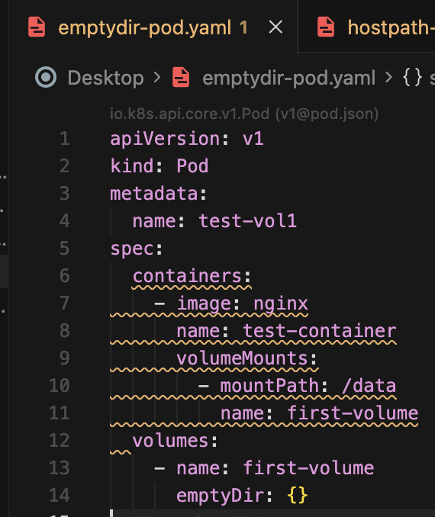

In this manifest:

The emptyDir volume is a temporary storage that is created when the Pod is assigned to a node and exists as long as the Pod is running.

Apply the manifest to create the Pod:
kubectl apply -f emptydir-pod.yaml

Step 3: Verify the Pod and Volume

Check the status of the Pod:

kubectl get pods
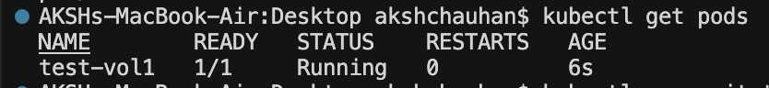
Access the Pod's shell:
kubectl exec -it test-vol1 -- bash

Inside the Pod, create a file in the /data directory:
touch f1 f2 f3

Exit the Pod shell:
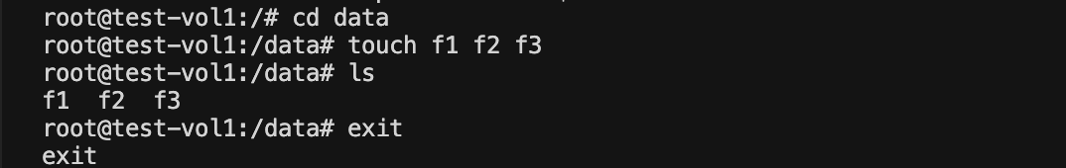
exit

Step 4: Create a Pod with a hostPath Volume
Create a file named hostpath-pod.yaml with the following content:

apiVersion: v1

kind: Pod metadata:
name: test-vol2 spec:
containers:
- image: coolgourav147/nginx-custom name: test-container volumeMounts:
- mountPath: /data name: first-volume
volumes:
- name: first-volume hostPath:
path: /test

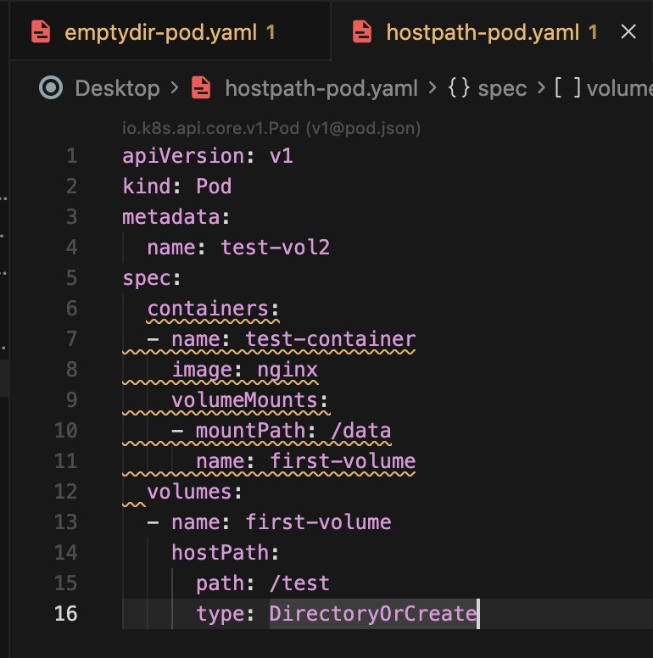

In this manifest:

The hostPath volume mounts a directory from the host into the Pod at /mnt/data. The busybox container writes the current date to a log file every 5 seconds.

Apply the manifest to create the Pod:

kubectl apply -f hostpath-pod.yaml

Step 3: Verify the Pod and Volume Check the status of the Pod:
kubectl get pods
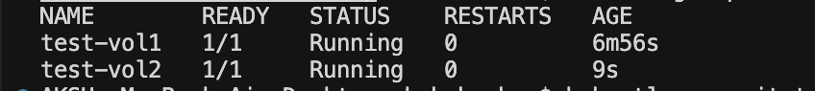
Access the Pod's logs to see the data being written:

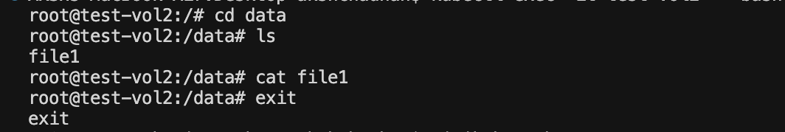
kubectl exec -it test-vol2 -- bash

You should see the dates being appended to the log file.

Check the host directory to verify the volume:

If you have access to the node running the Pod, you can verify the data in
/tmp/data/log.txt.

